Special Note about the 4-channel ULS24 Solution Kit

The 4 sensor modules are individually labeled by their chip ID. They must be plugged into the corresponding sensor interface channels (Ch1, Ch2, Ch3, Ch4) on the uC Interface Board for the system to function correctly.

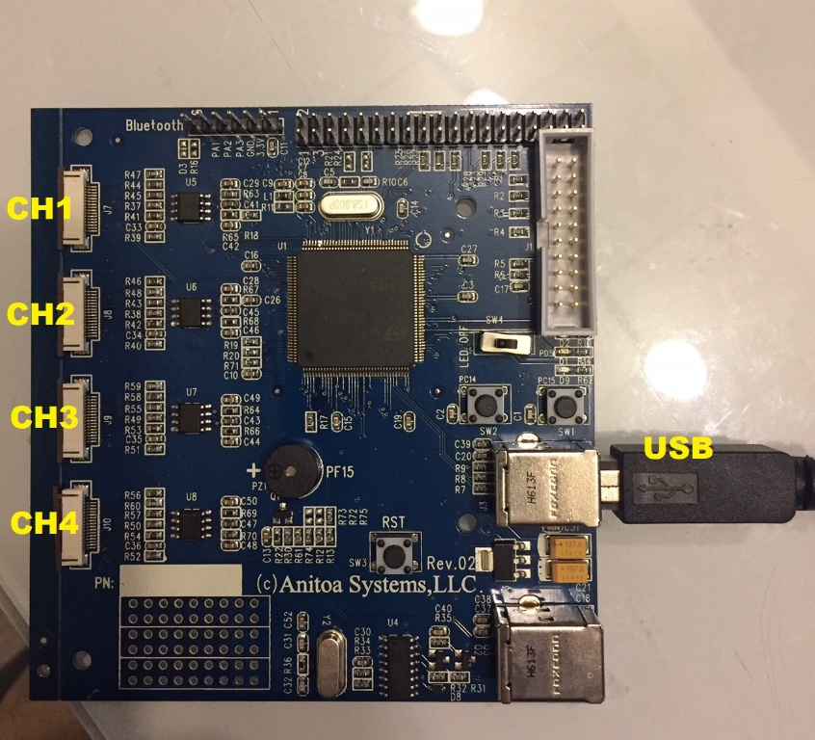

Channel | Connector on main board | Chip ID
1 | J7 | 607
2 | J8 | 216
3 | J9 | 612
4 | J10 | 208

Kit Content

Sensor module - These are sensor modules, which contain the ULS24 Ultra low-light CMOS imager chips. On the back of the Sensor modules are 16-pin ribbon cable connectors (Ch1, Ch2, Ch3, Ch4) for connection with the uC Interface board.
uC Interface board - This board contains an STM32 ARM Cortex-M3 microcontroller. The system firmware is pre-programmed into the microcontroller. The Interface board connects with the sensor modules through a 16-pin ribbon cable. Interface board also connects to a PC through USB interface.
USB cable - This connects the uC Interface Board with the PC.
Dongle w/ software - It is a USB Flash Drive that contains all the software and documentation.

ULVision4ch.exe

This is a software customized for the ULS24 Solution Kit 4 Channel System. ULVision4ch is a PC software that displays captured image and allow user to enter control parameters.

Getting started guide

Below is a step-by-step instruction to set up the whole system and test the basic functions.

- Visually inspect the components of the kit to make sure nothing is damaged. If damages are found, please contact Anitoa Systems, LLC (info@anitoa.com) to request a replacement.

- Connect the Sensor modules with the uC Interface Board - follow instructions in Appendix B, insert and lock the ribbon cable with connectors on the Sensor Board and uC Interface Board. The metal contact portion of the ribbon cable end should face down.

- Install Software on a PC. Insert the included USB Flash Disk into a PC. Copy ULVision.exe from the folder ULVision to any directory in the PC.

- Connect and power on uC Interface Board - Connect the uC Interface Board with the PC using the included USB Cable. The USB provides power to the whole system. When connected, the LED on the uC Interface board will start flashing.

- Start ULVision on the PC. If the uC board is already plugged in, it will automatically connect to ULVision. The status should display "ULS24 Device Detected".

- With all parameters taking their default value, place the sensor in a dark area, click on "Capture" button, you should see a gray scale image displayed. Adjust the integration time to achieve best exposure.

Note: Because of the high sensitivity of this sensor, under normal illumination level, the sensor would likely saturate. When the sensor saturates, the output from the affected pixels will not be updated.

Appendix A: ULS24 Pixel format and binning pattern explained

The orientation of the chip relative to the package is shown below.
Chip package
Sensing area

Figure 3 Chip orientation and pixel format

The pixels of the imager are arranges as a matrix shown below. Each big pixel is comprised of 4 subpixels.

Figure 4a, Pixel binning pattern

In 12X12 low resolution mode, each effective pixel is comprised of 4 subpixels. Any combination of the 4 subpixels can be chosen to sense light. When more than one subpixel is chosen, the sensitivity is multiplied. For example, if all 4 pixels are chosen, the sensitivity of the device is quadrupled.

Appendix B: 16-pin Ribbon Cable and Connector Guide
Do not pull the tab too hard or it will break.

